ClassAssignment2 Report

**2016025041** 하태성

* **Manipulating Camera as in ClassAssignment1 + Draw Grid Plane**
  + Perspective & Orthogonal

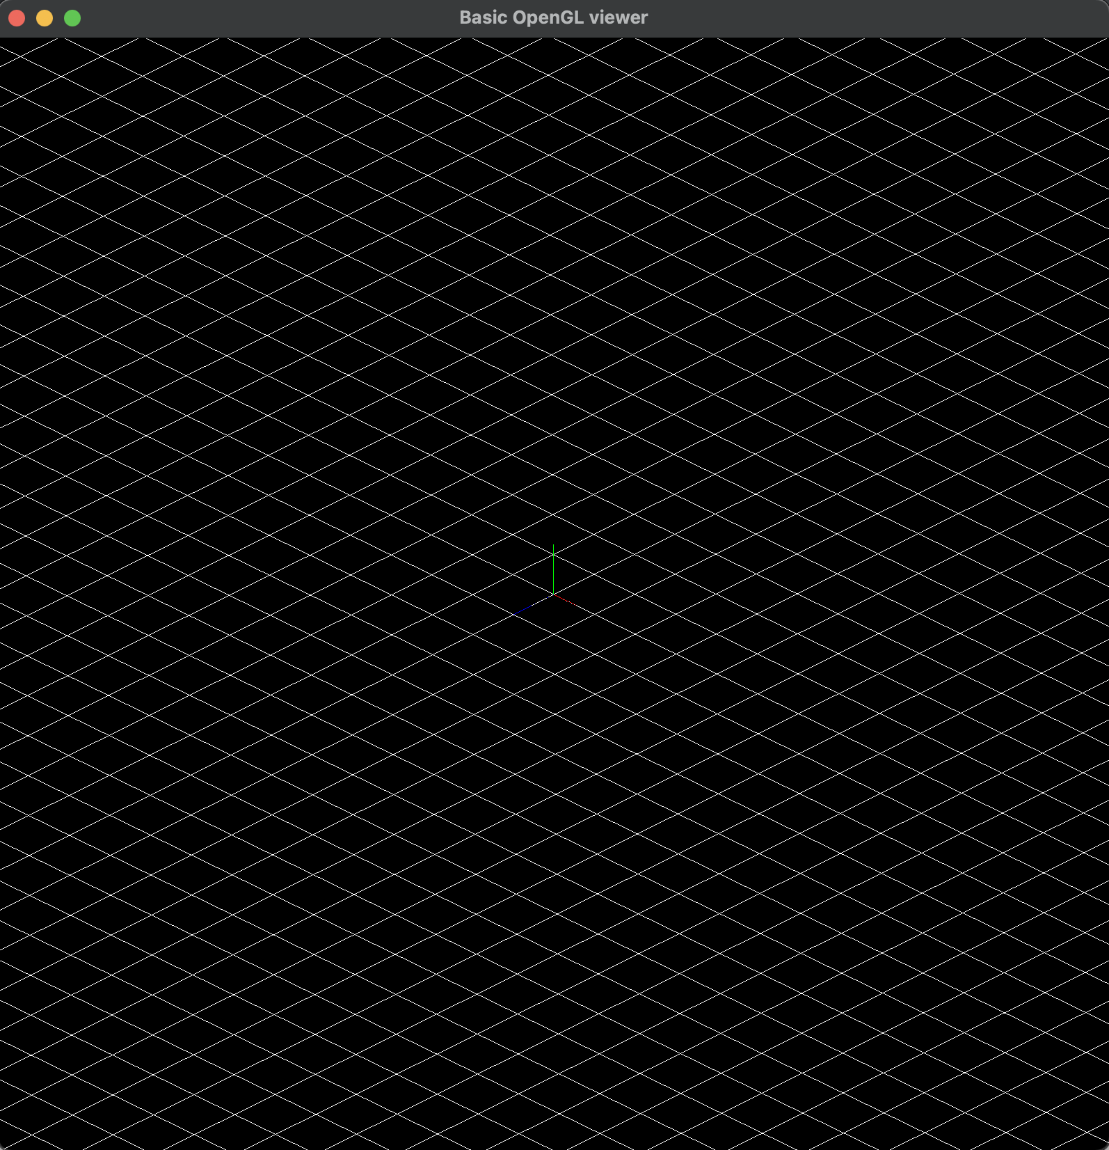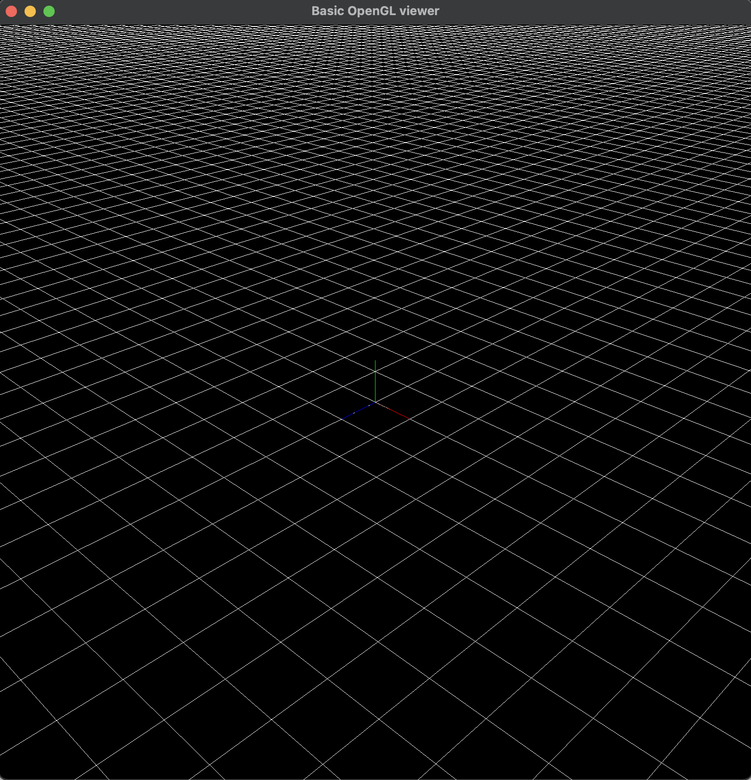

* **Open obj file by Drag-and-Drop**
  + cube.obj / cylinder.obj / 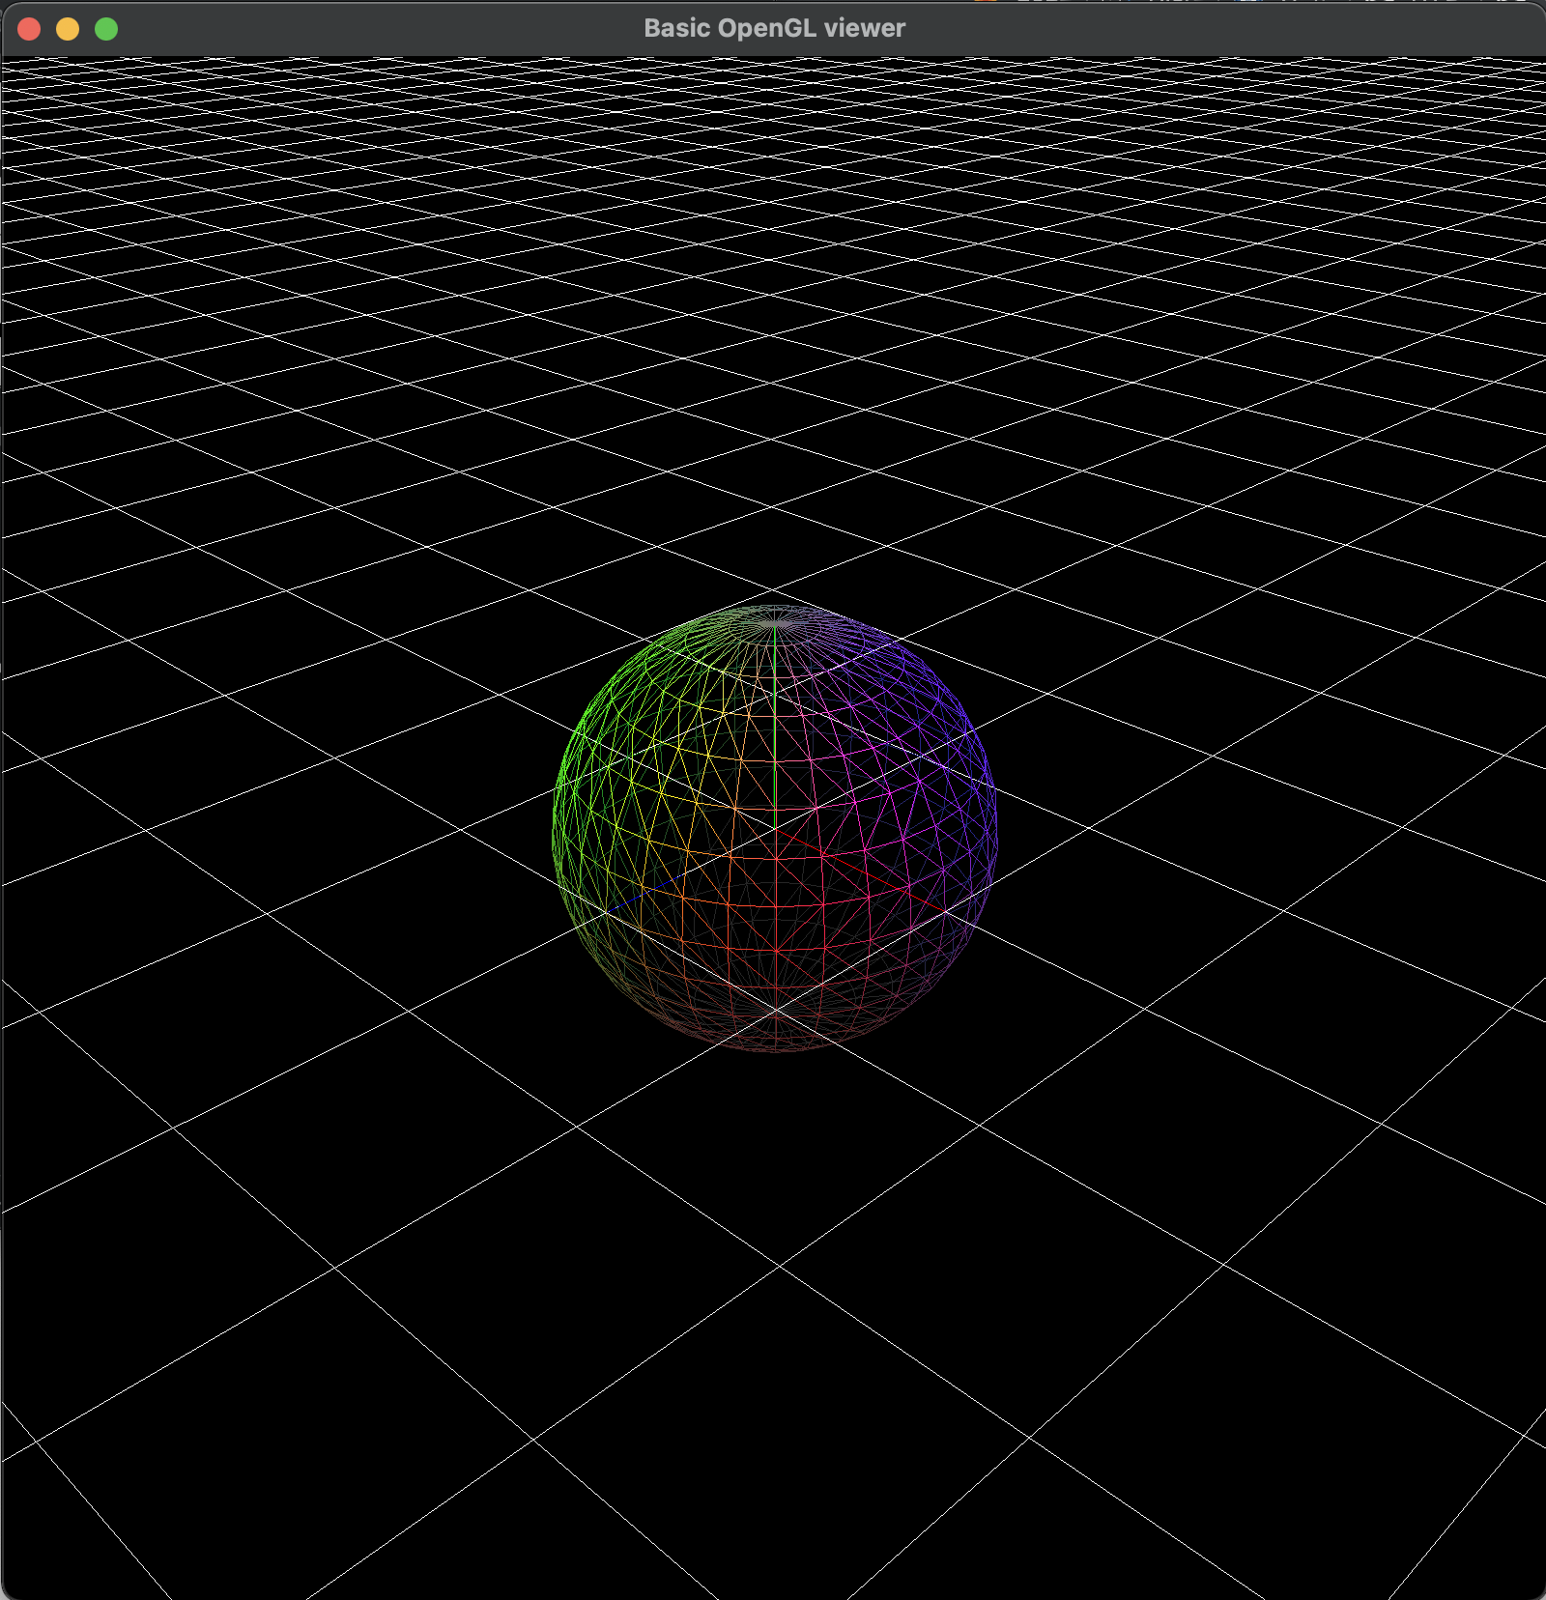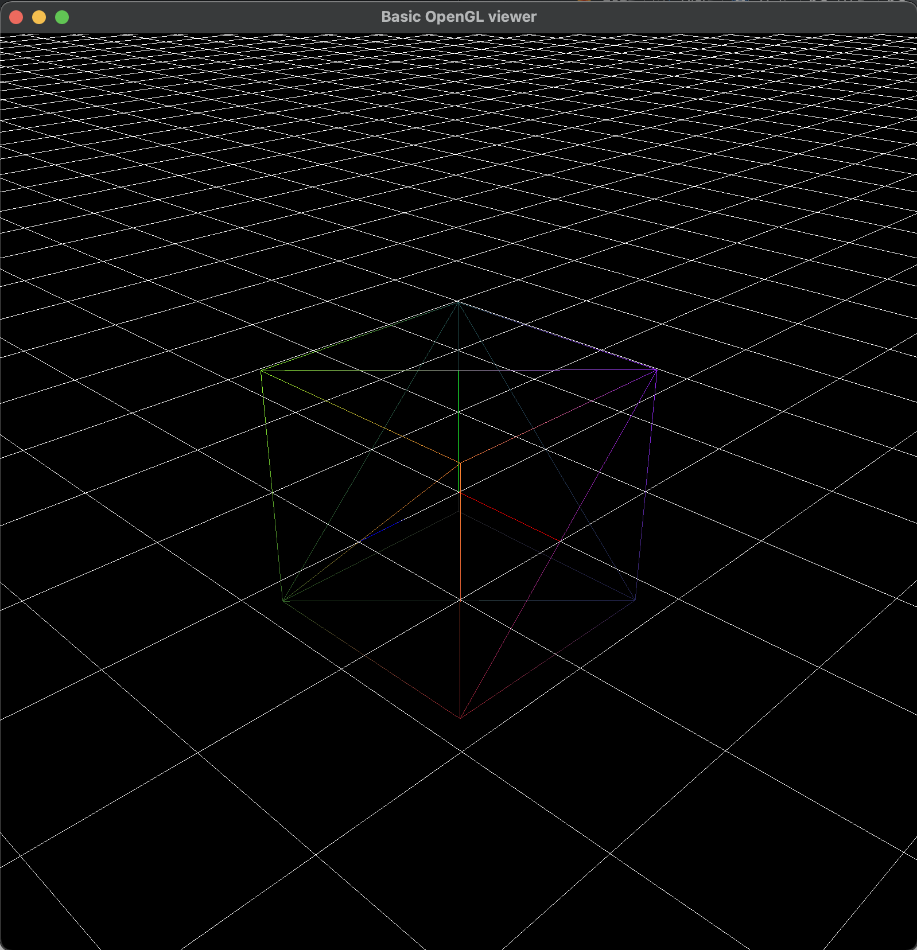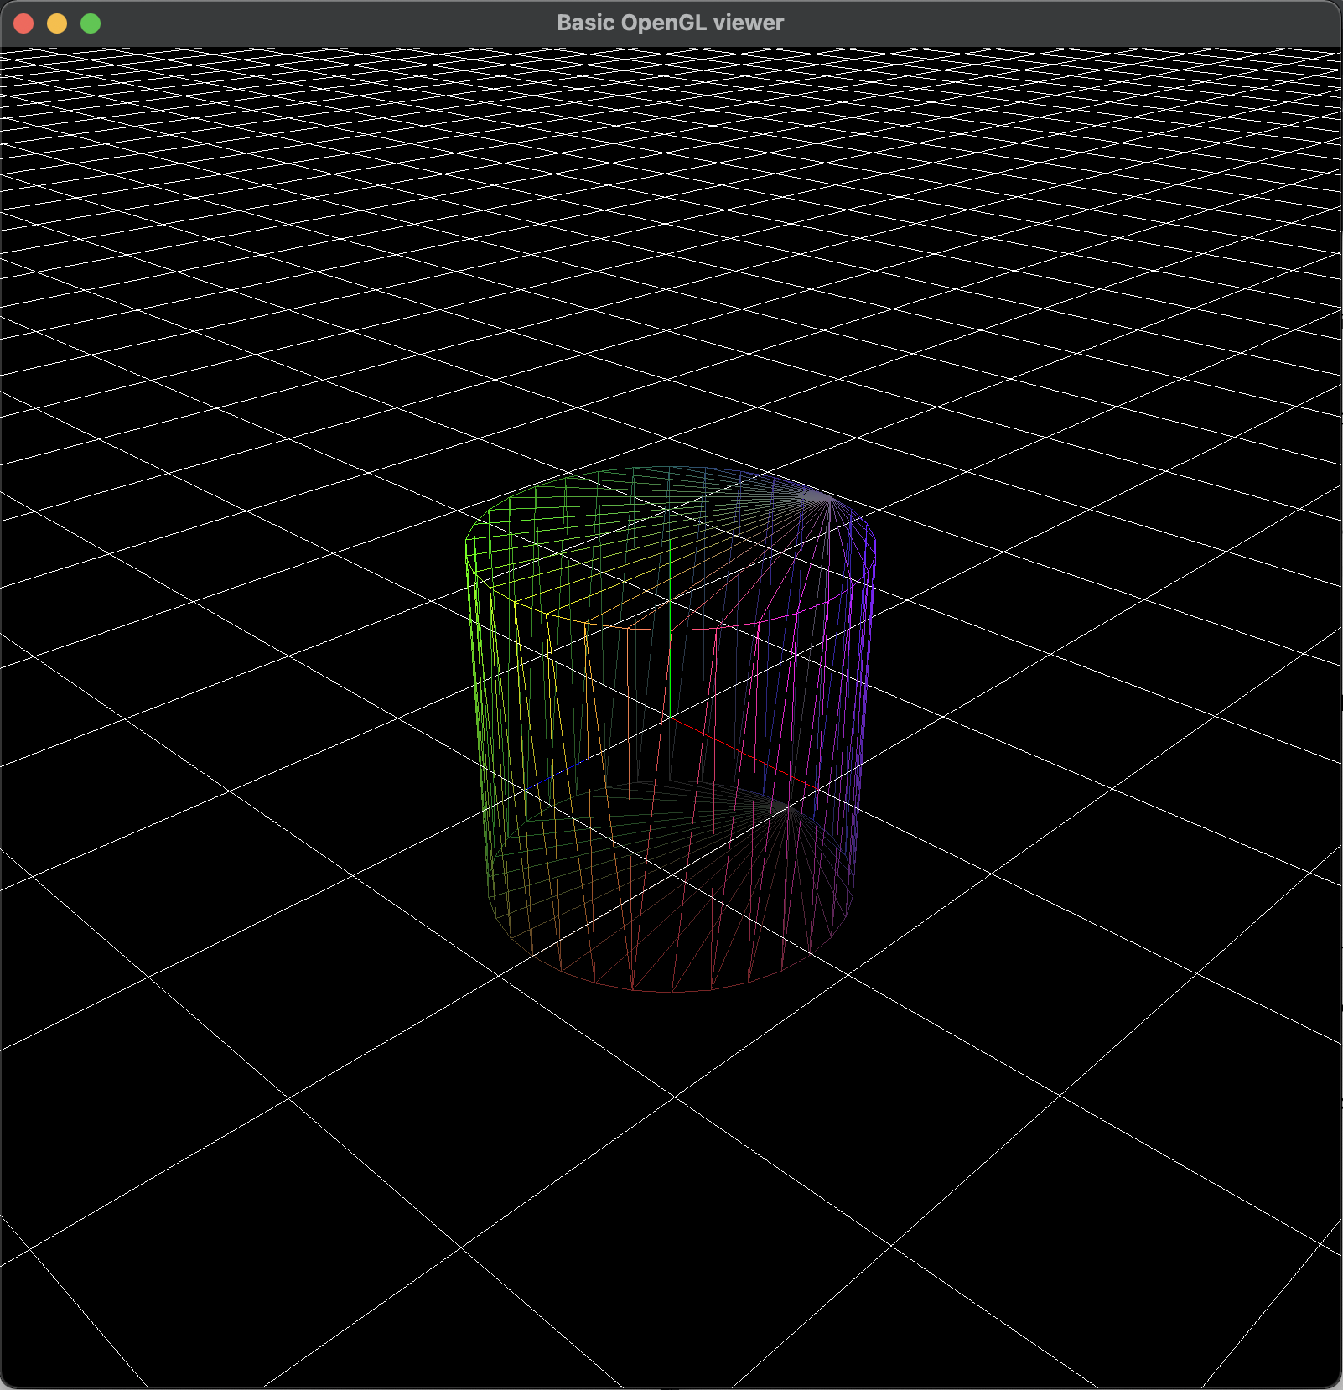sphere.obj
* 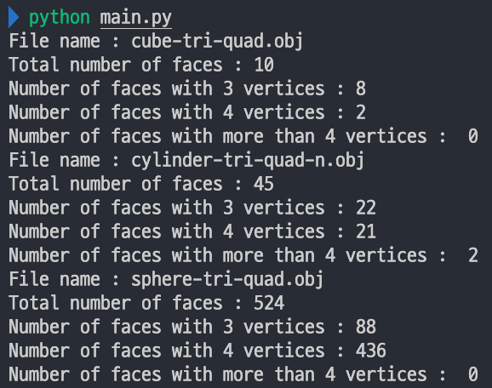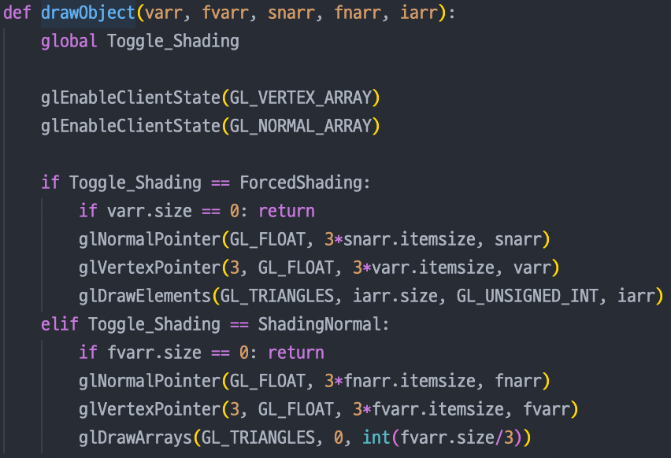**Use glDrawArrays() or glDrawElement() / Print Information to stdout**
* **Animating Hierarchical Model Rendering Mode**
  + at least 3 different meshes loaded from 3 different downloaded obj files
  + Use os.path.join()

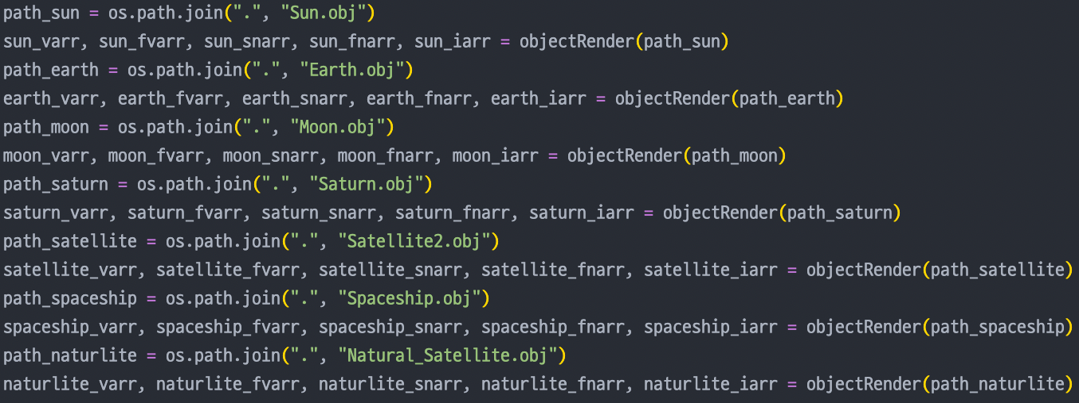

* **Hierarchical Model with Using OpenGL matrix stck**
  + 3 levels and each node have 2 childs / Animate - 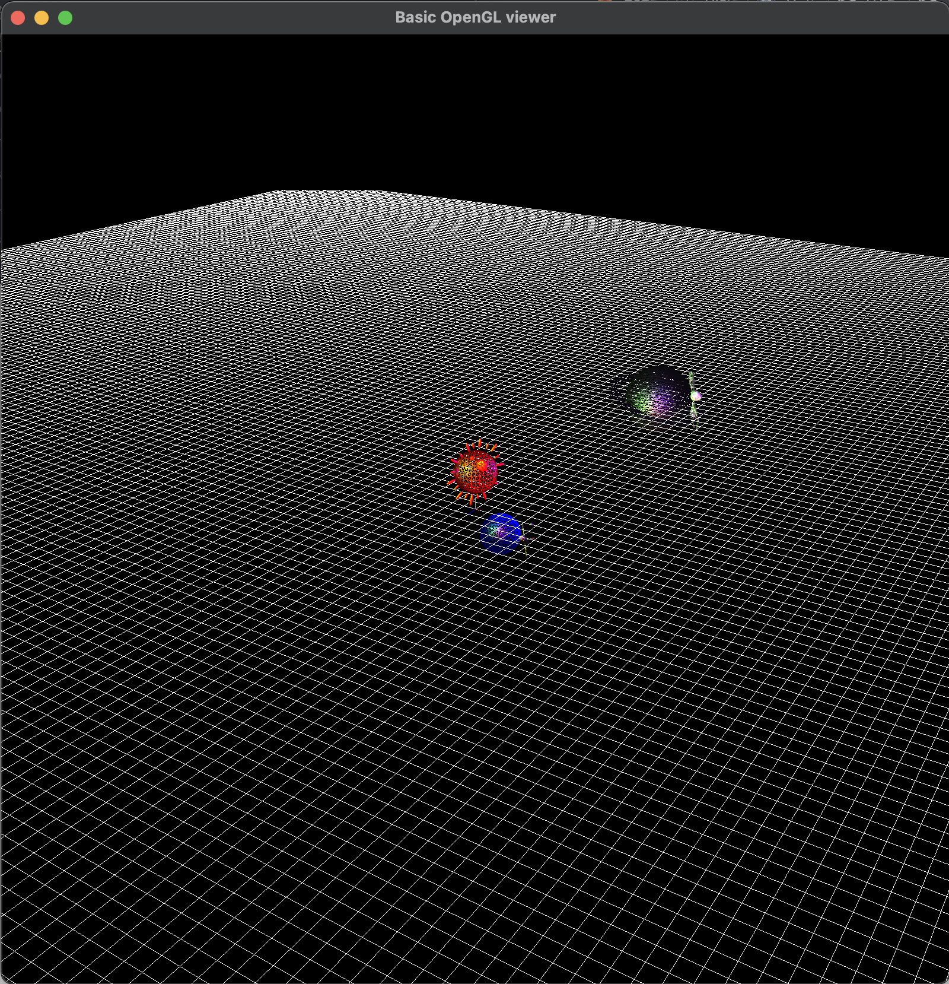relative move
  + Hyperlink : https://youtu.be/3T9R72P8IHg
* **Lighting**  - **Etc & Extra Credits**
  + 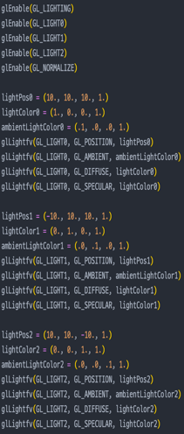 3 light source * Toggle shading
  + put at (10, 10, 10)   
    / (-10, 10, 10) / (10, 10, -10)

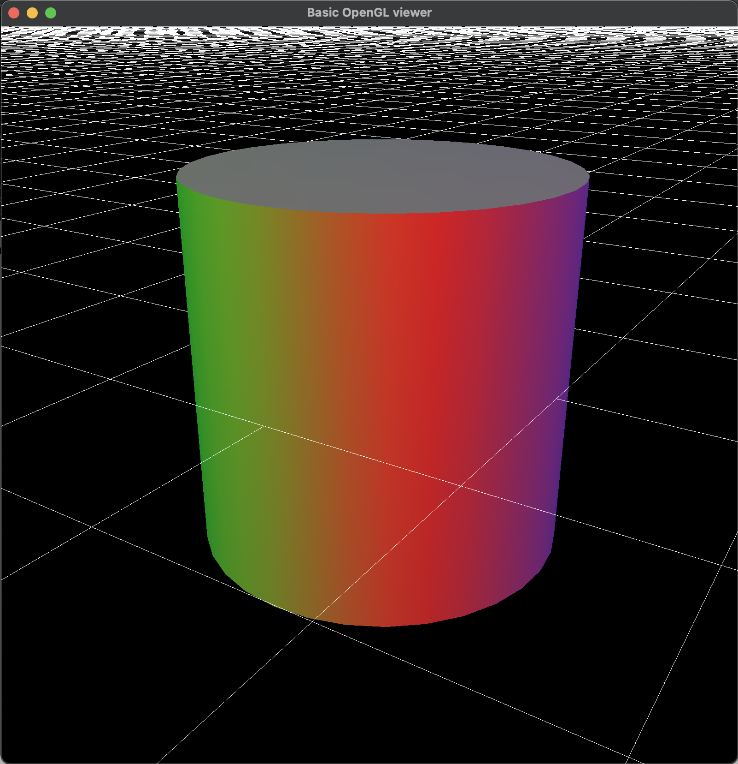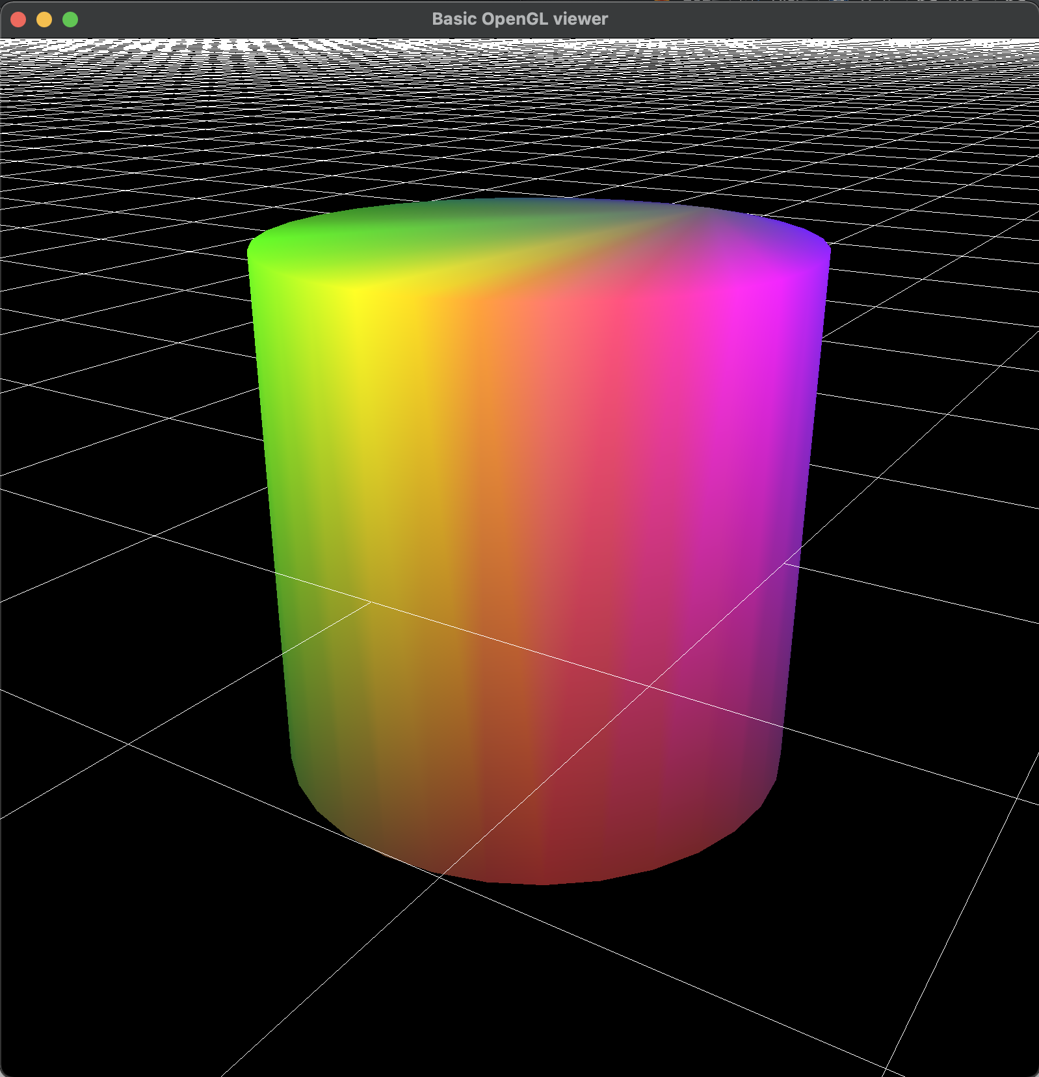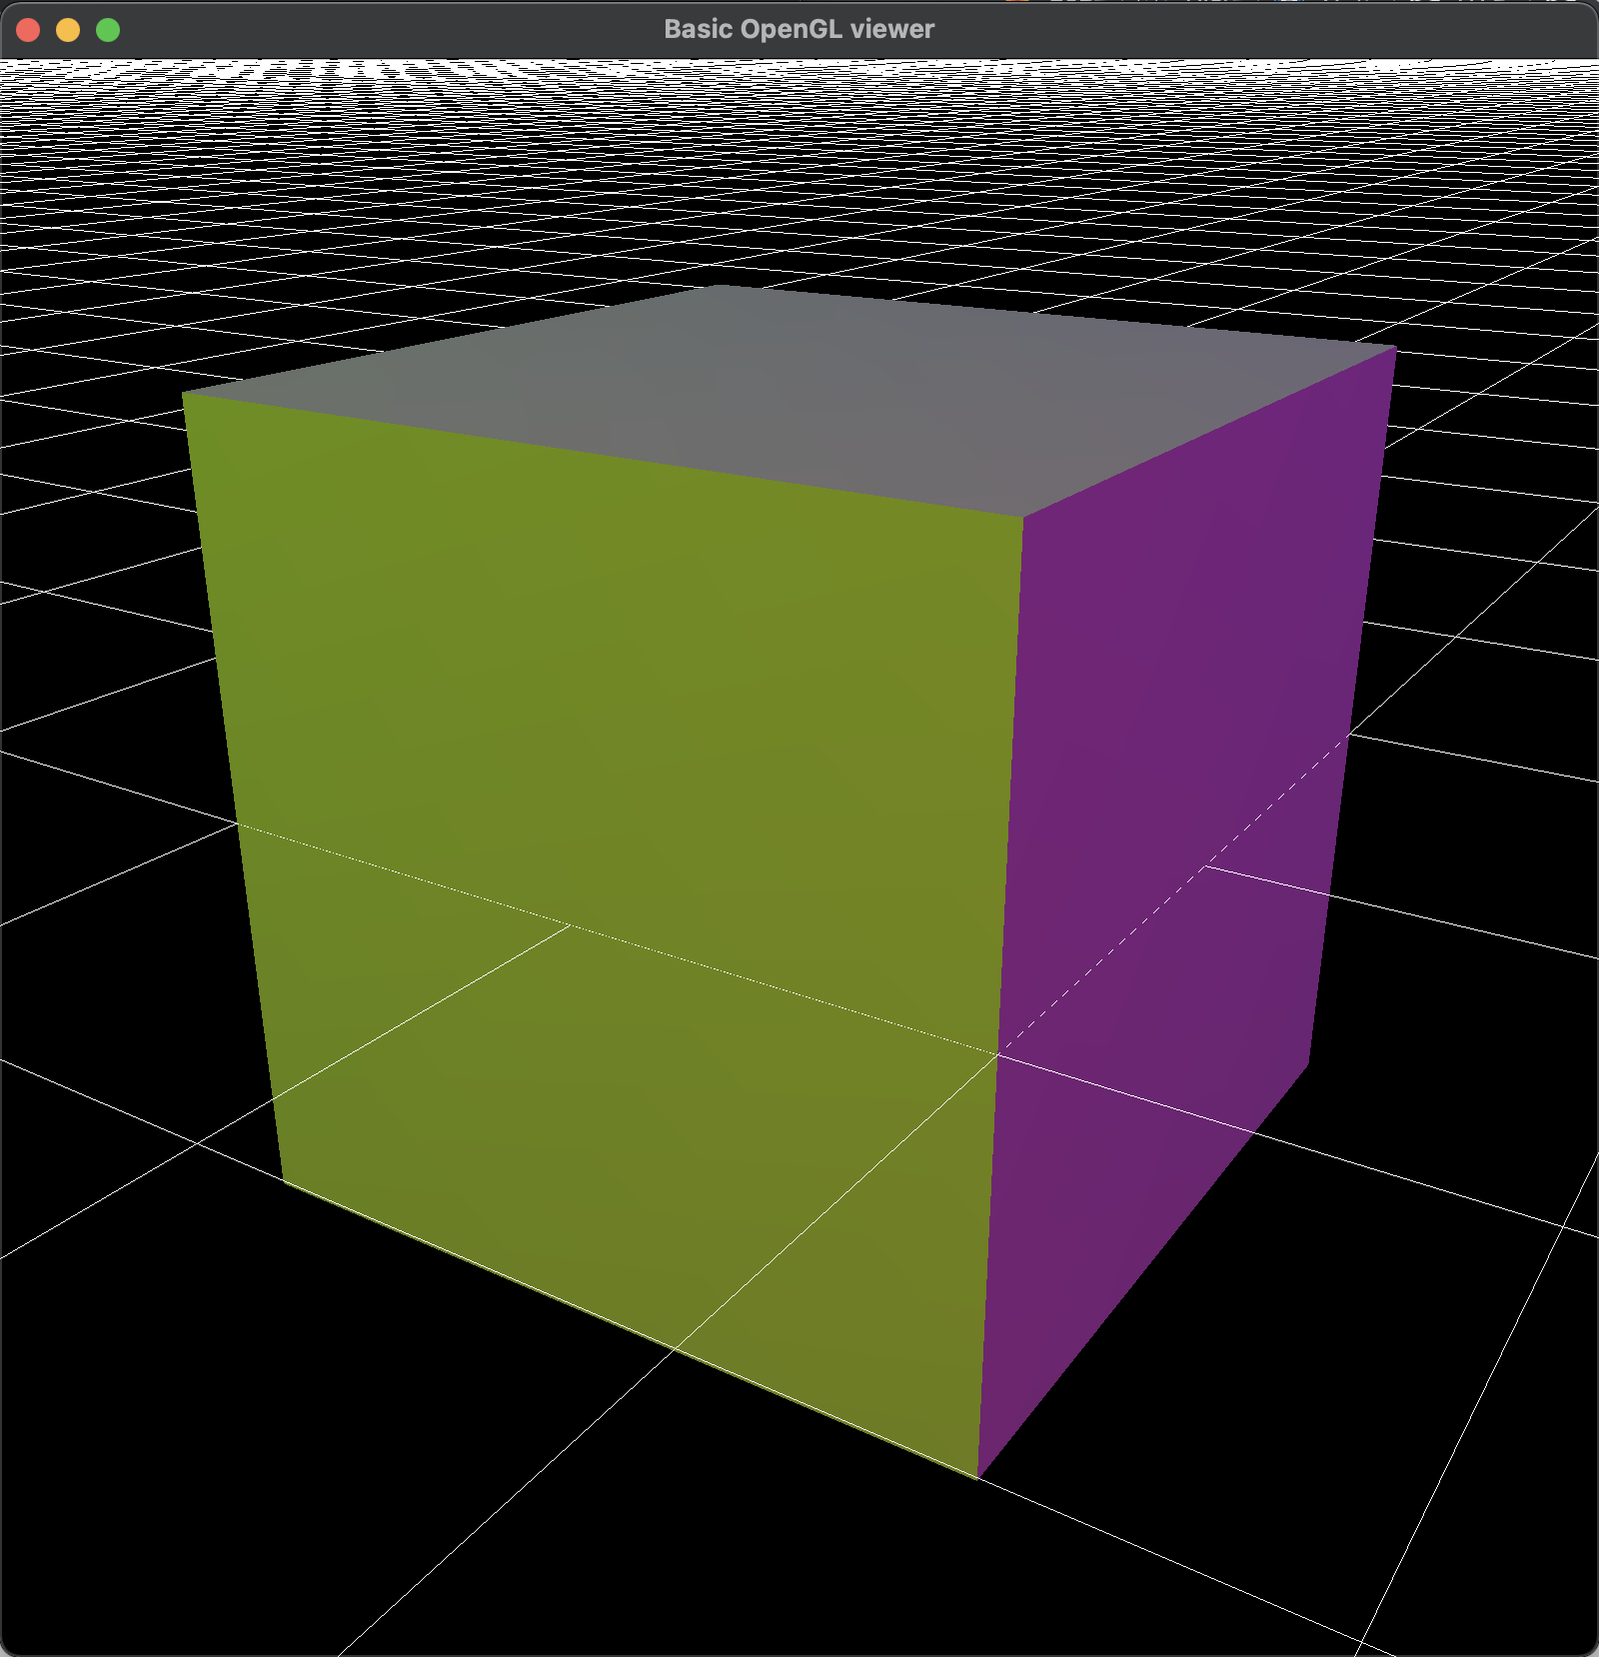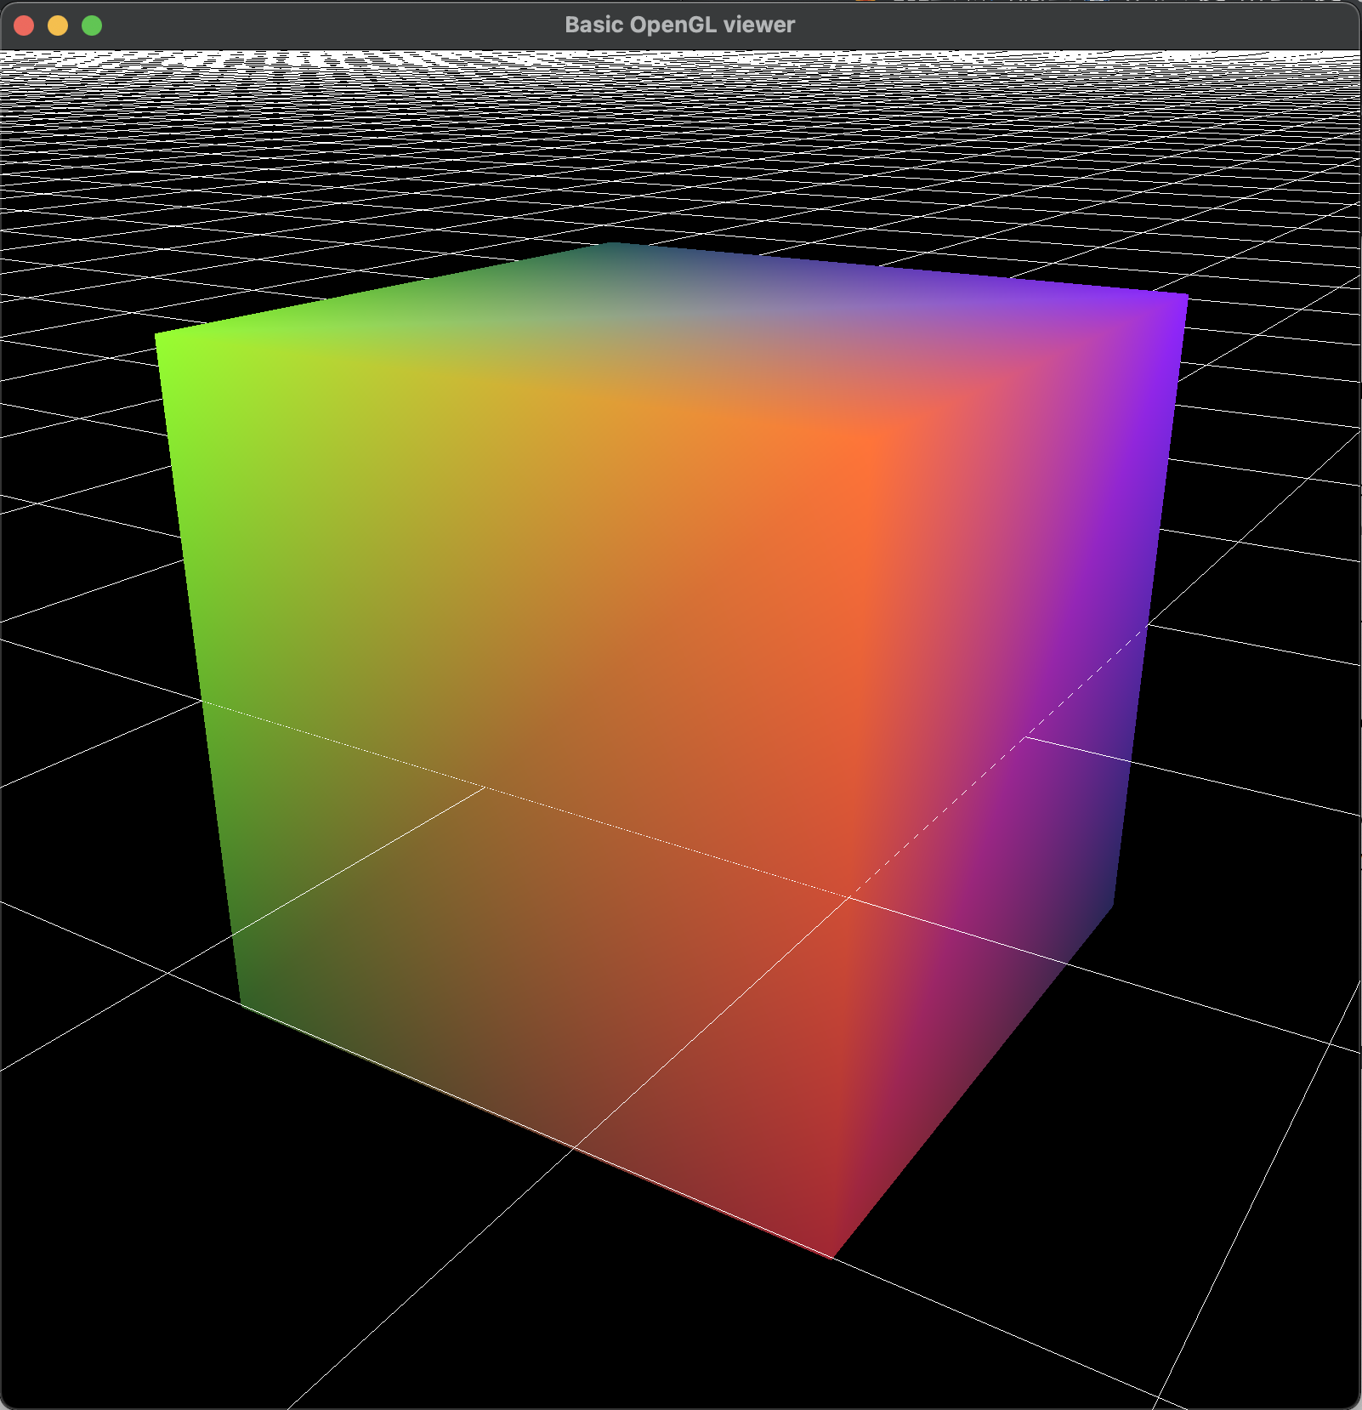

* + directional light

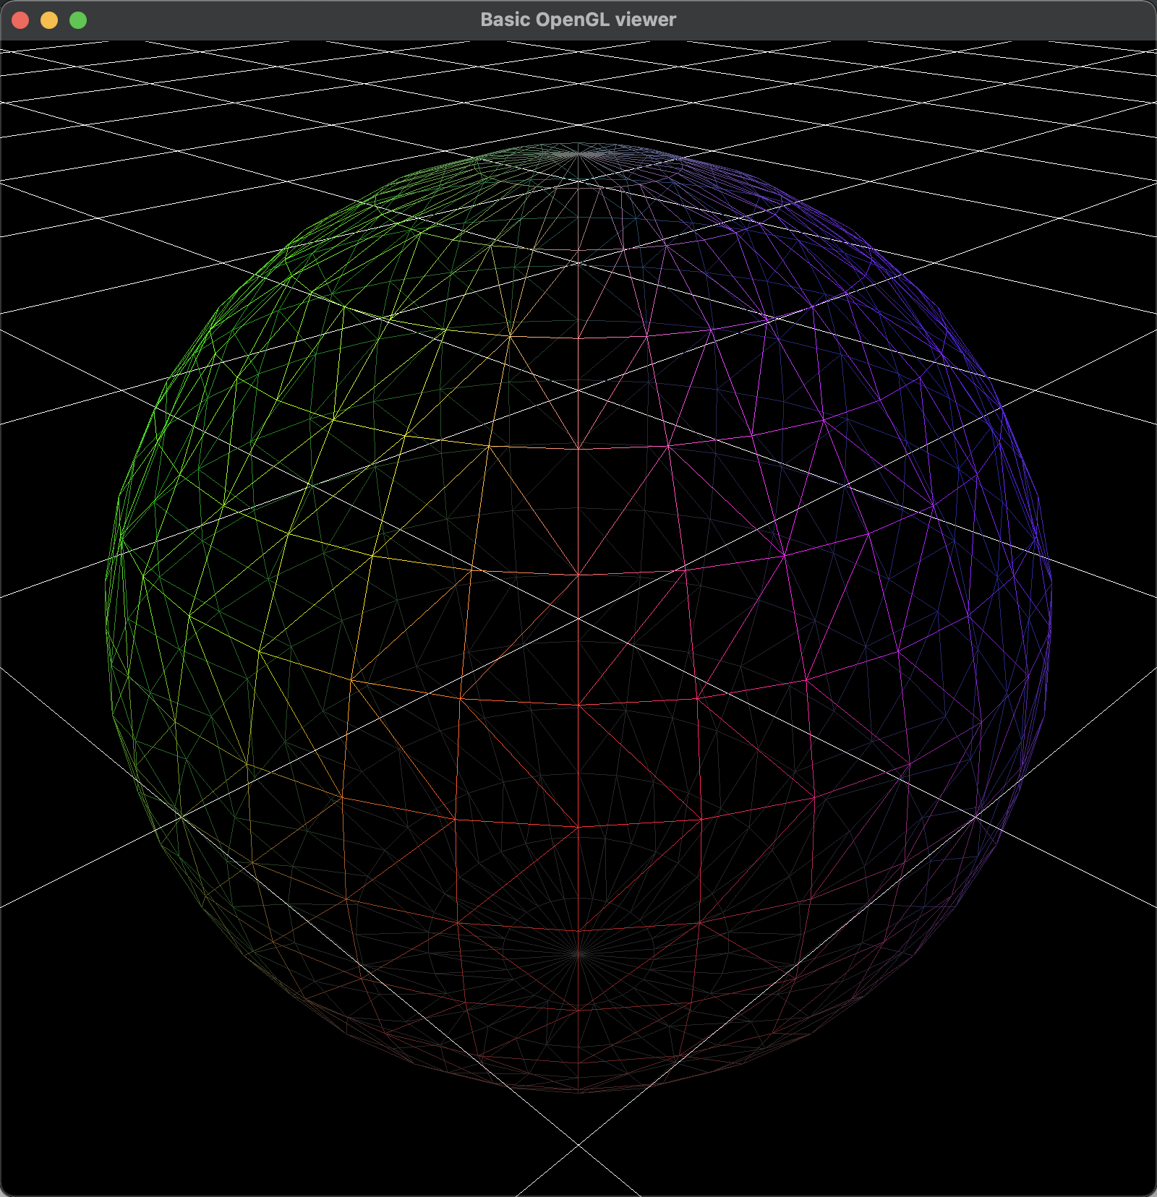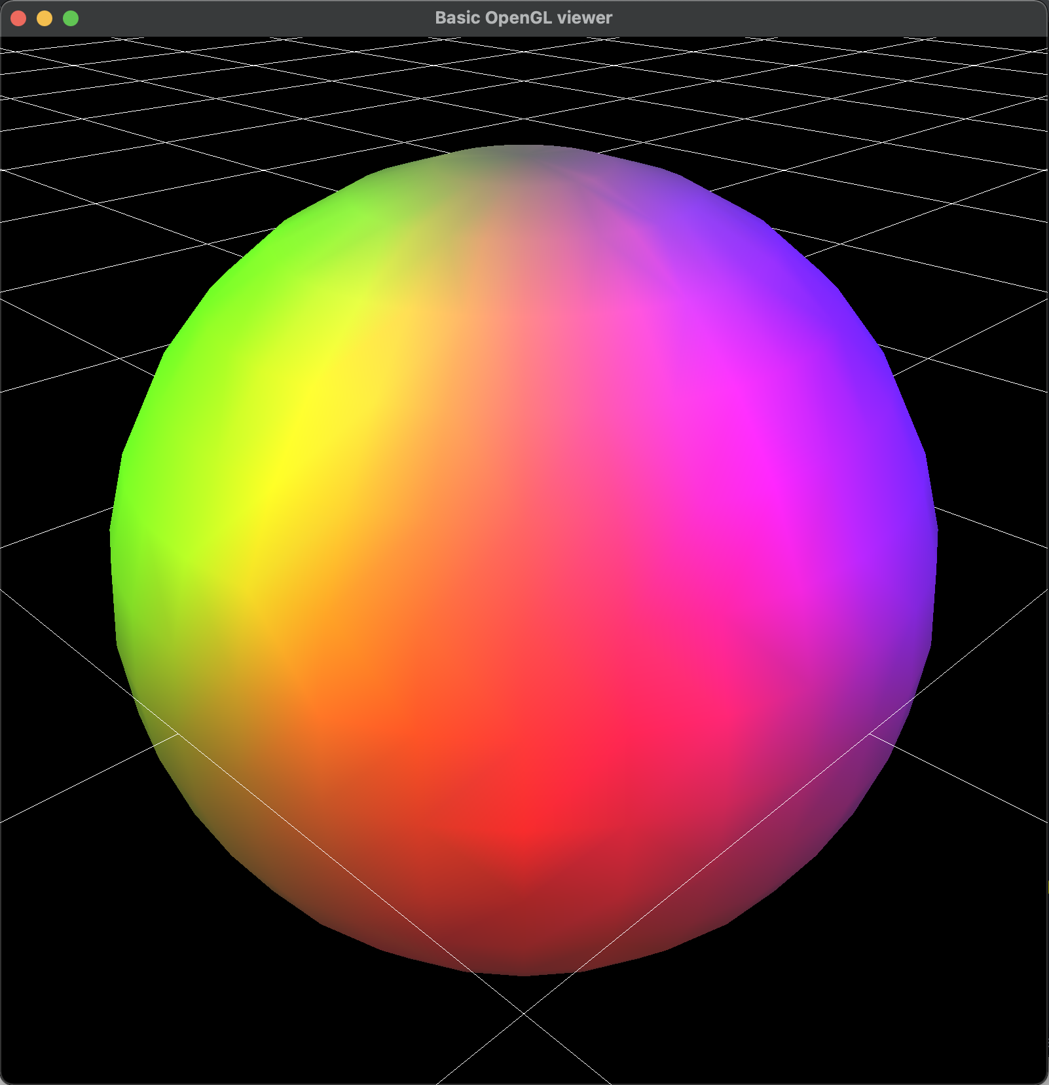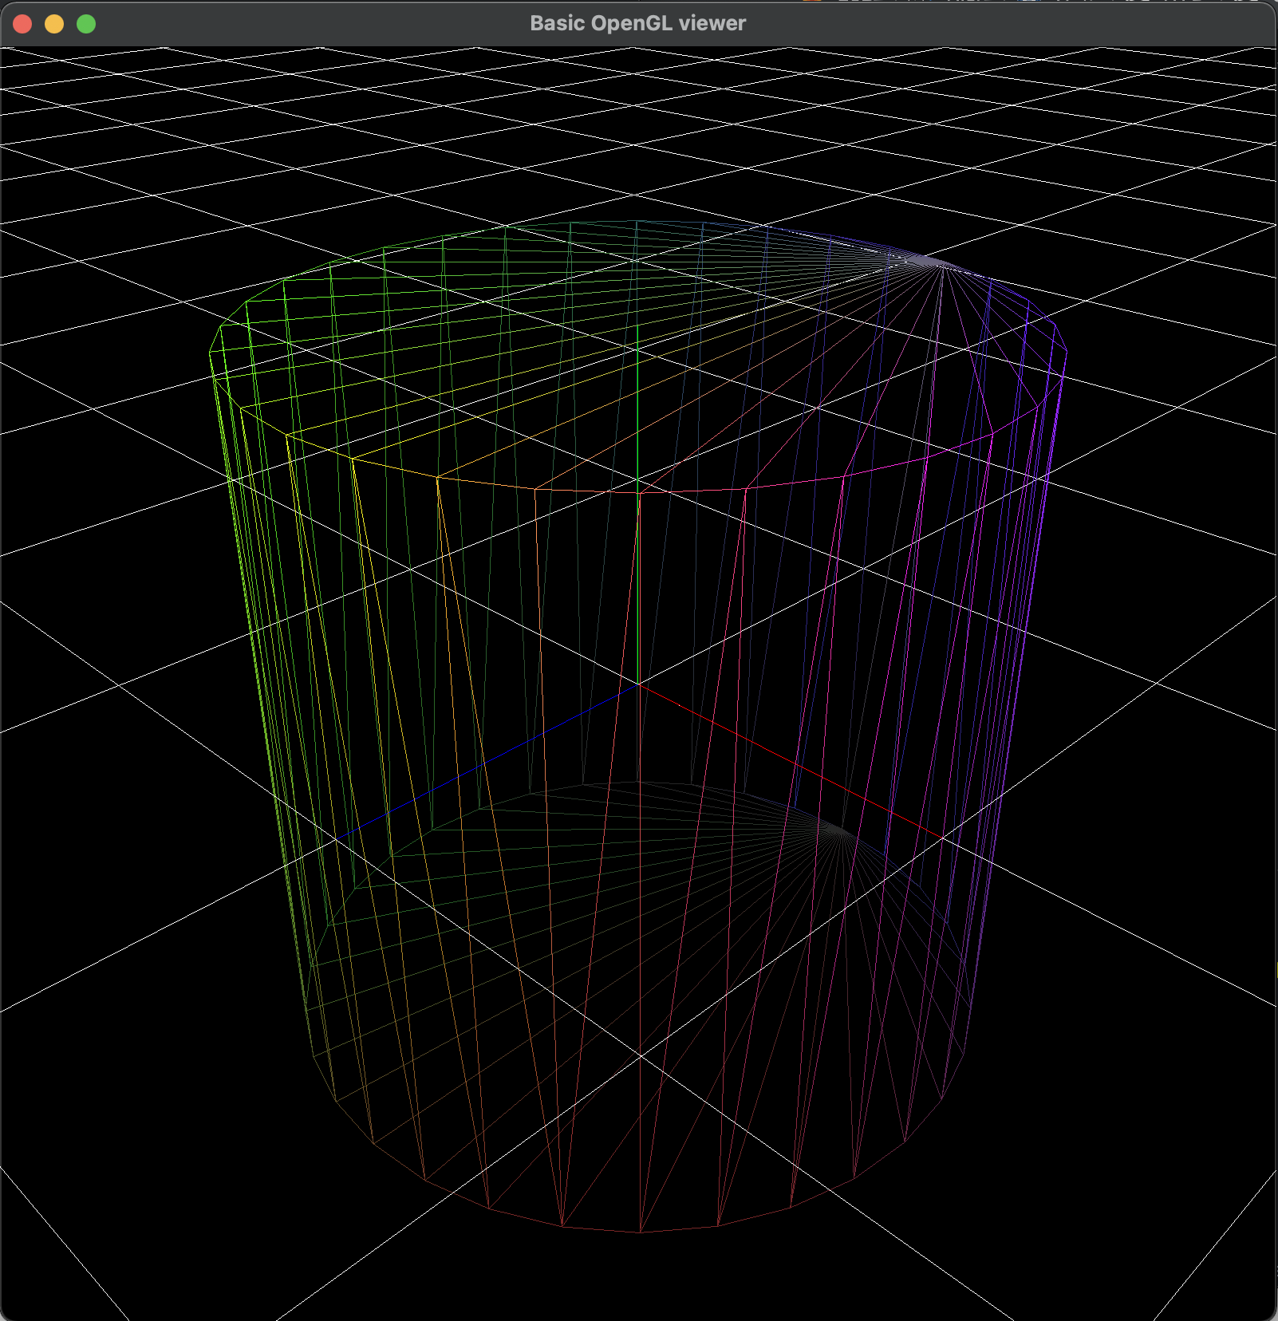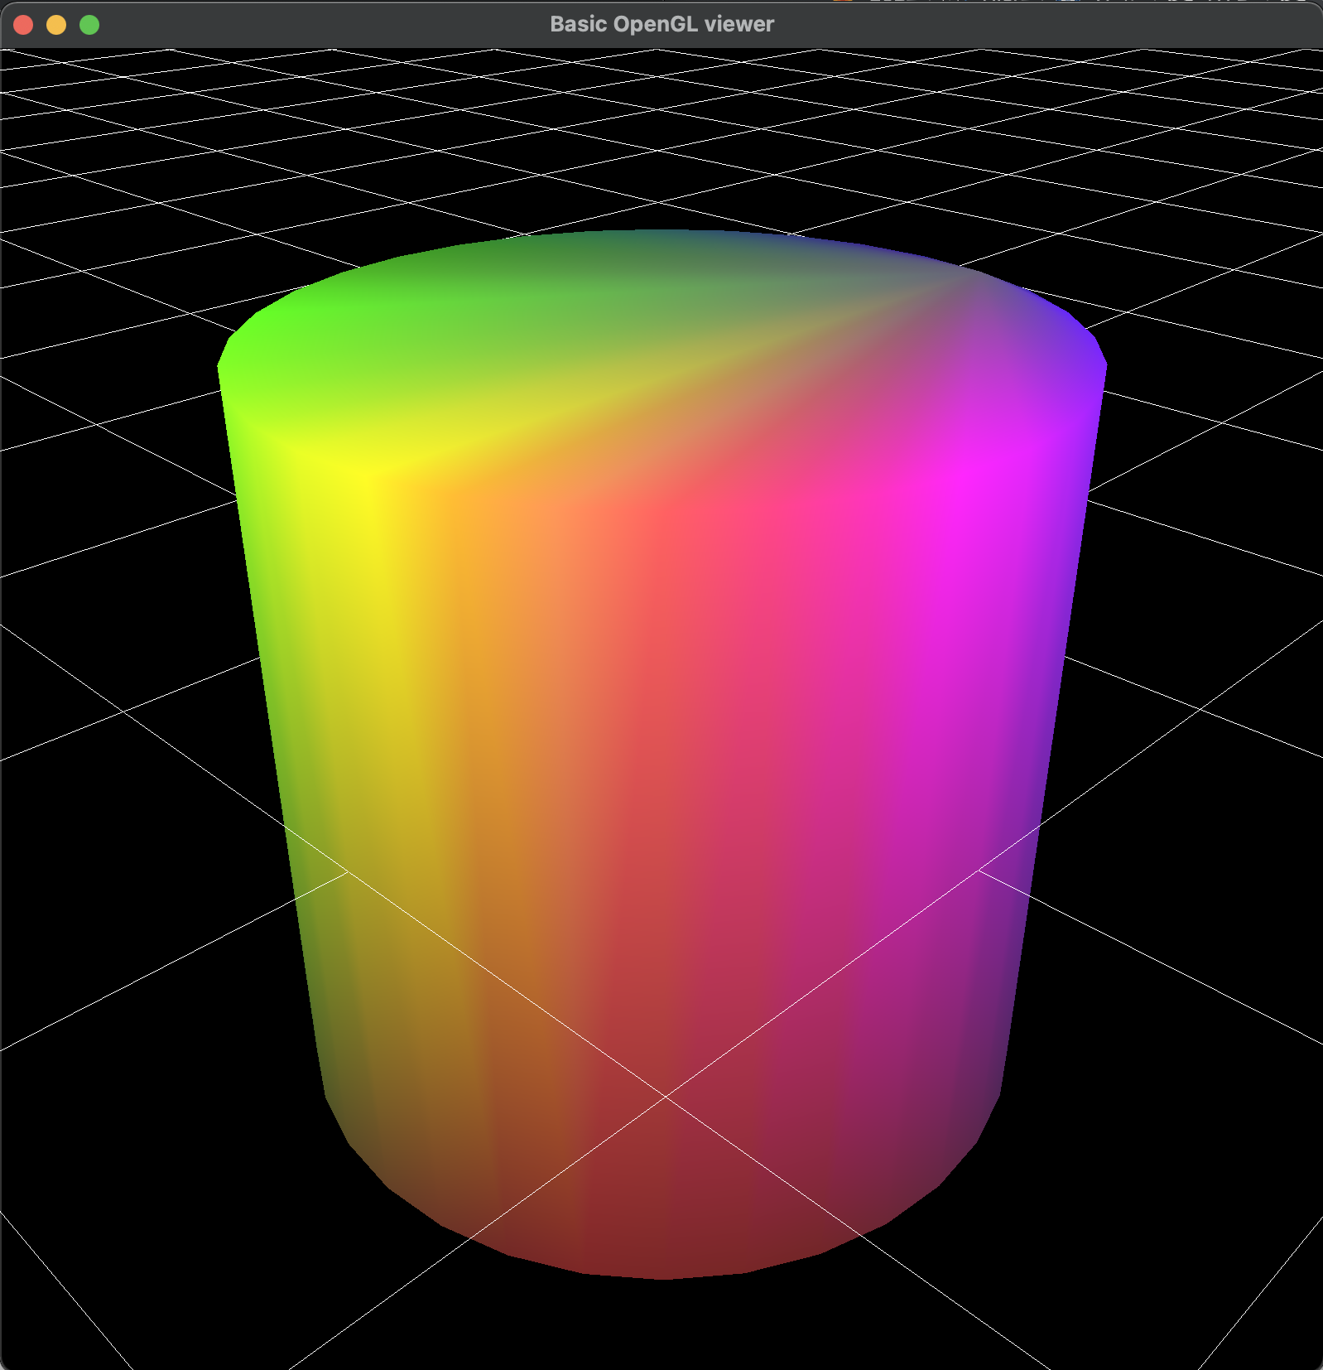

* Toogle wireframe / solidmode

* Triangulation  
 - No gl_QUADS & gl_POLYGON  
 - Only Triangle mesh with gl_TRIANGLES

* **All Requirement Implemented!!**